***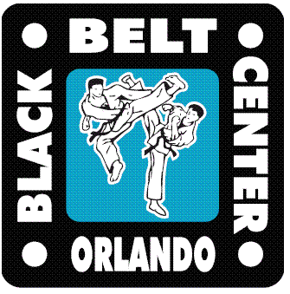* BLACK BELT CENTER**

**PRESENTS**

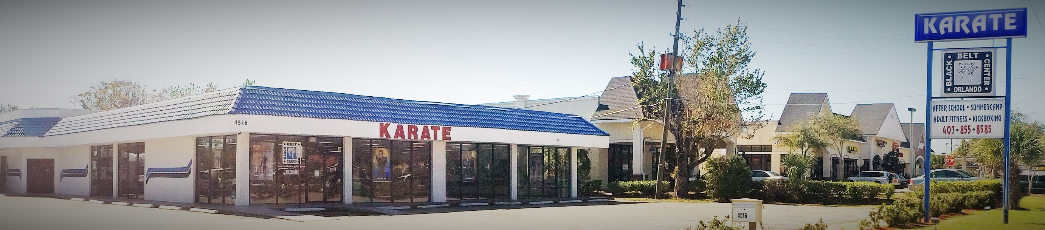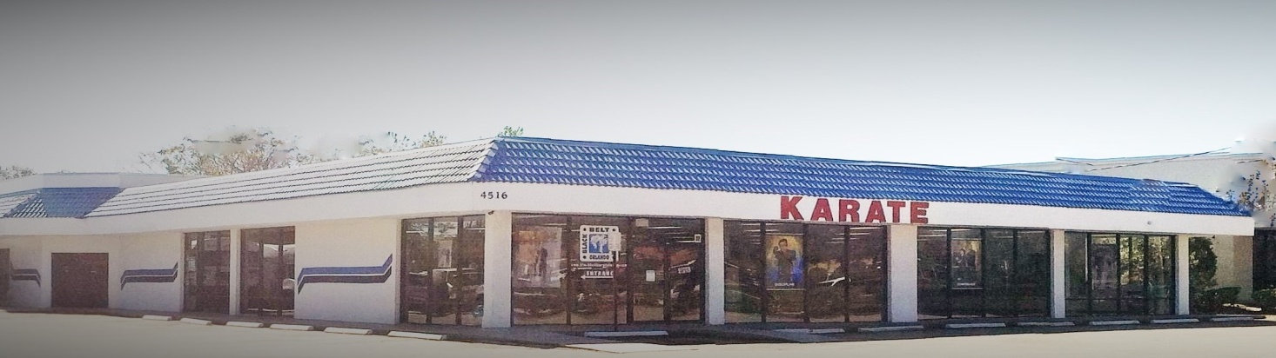 **SUMMERCAMP**

**DISCOUNT DEADLINE 4/15**

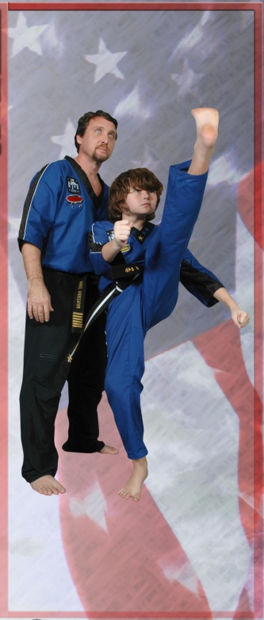

*FILLING UP FAST*

REGISTER NOW

$20 OFF REG & WKLY FEE W/ FLYER

**‘BE A PART OF THE BEST SUMMERCAMP’**

**\* * * * * * * * * * * * * * * * * * * * * * * * * * * * * * * * \***

***We have an exciting summer planned***

***for your child. Everyday filled with***

***lots of fun activities including:***

**MARTIAL ARTS CLASSES**

**WEAPONS SEMINARS**

**3 FIELD TRIPS EACH WEEK**

***WONDERWORKS – BOWLING SCIENCE CENTER - MONKEY JOES***

***SKATING – BOWLING - MOVIES***

***SWIMMING AND MUCH MORE!!!!***

**REGISTER FOR A WEEK OR THE WHOLE SUMMER**

**(Daily rates available)**

**June 1th thru August 7TH**

***4C ACCEPTED***

***We are a State Licensed Facility***

***License # CO90R0033***





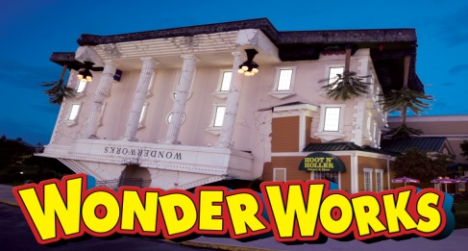

***CALL NOW 407 855-8585***

**VISIT OUR 10,000 Sq Ft FACILITY**

[**www.blackbeltkaratecenter.com**](http://www.blackbeltkaratecenter.com)

**www.facebook.com/blackbeltkaratecenter**

***4C ACCEPTED***

***We are a State Licensed Facility***

***License # CO90R0033***

|  |
| --- |
| **Located at 4516 Hoffner Ave Directly ACROSS HOFFNER From Wells Fargo & Publix** |