***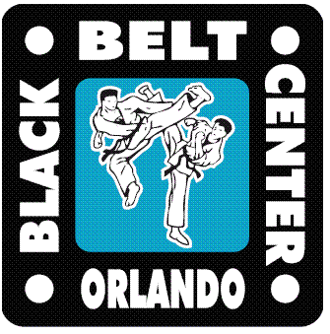* BLACK BELT CENTER**

**PRESENTS**

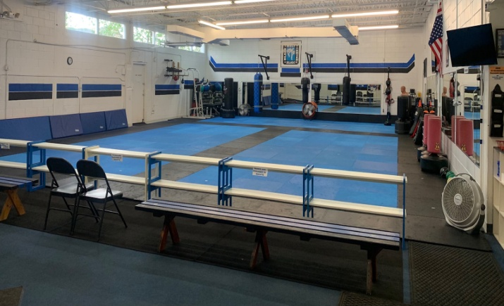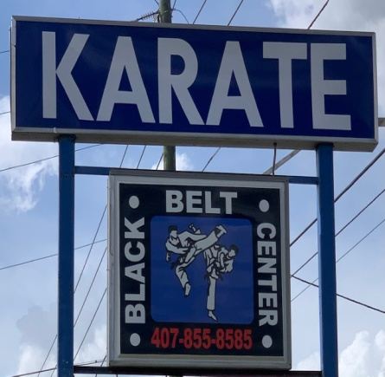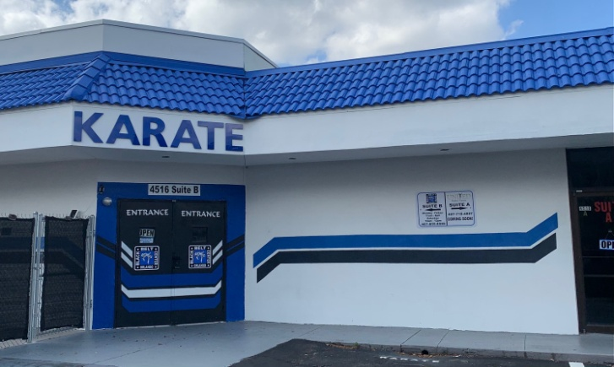 **SUMMERCAMP**

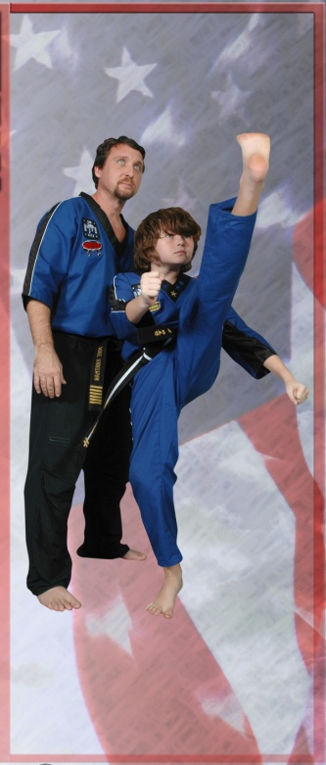 DEADLINE APRIL 15TH

\**LIMITED SPACE\**

REGISTER NOW

$20 OFF REG & WKLY FEE W/ FLYER

**‘BE A PART OF THE BEST SUMMERCAMP’**

**\* * * * * * * * * * * * * * * * * * * * * * * * * * * * * * * * \***

***We have an exciting summer planned***

***for your child. Everyday filled with***

***lots of fun activities including:***

**MARTIAL ARTS CLASSES**

**& WEAPONS SEMINARS**

**FIELD TRIPS & OUTDOOR ACTIVITIES EACH WEEK**

**(Daily rates available)**

**SESSON #1 June 5 – June 30**

**SESSION #2 July 10 – August 4**

***4C ACCEPTED***

***We are a State Licensed Facility***

***License # CO90R0033***







***CALL NOW 407 855-8585***

**VISIT OUR FACILITY & FREE INTRO CLASS**

[**www.blackbeltkaratecenter.com**](http://www.blackbeltkaratecenter.com)

**www.facebook.com/blackbeltkaratecenter**

***4C ACCEPTED***

***We are a State Licensed Facility***

***License # CO90R0033***

|  |
| --- |
| **Located at 4516B Hoffner Ave Directly ACROSS HOFFNER From Wells Fargo & Publix** |